NU Racing 2019 ESF Addendum

2019 28/11/2019

# Safety circuits – amendments

4.1 – TSAL redesigned with the following schematic (addendum implemented)

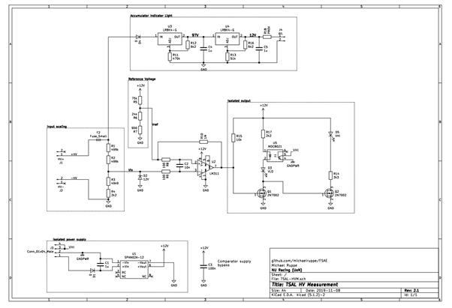

*Figure 4‑2: TSAL HVM schematic*

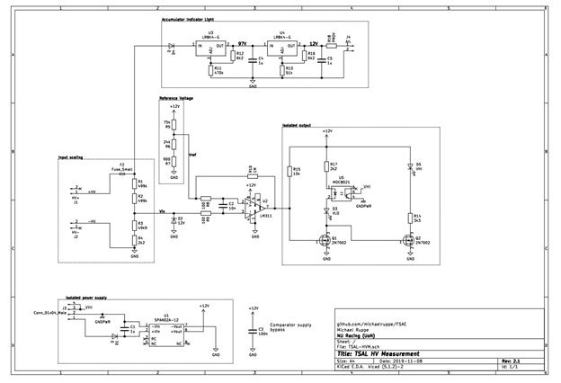

*Figure 4‑2: TSAL HVM schematic*

4.2 – Measuring points: The water proofing For The measurement points is no longer a box but uses IP67 bananas leak plugs to insulate the ports from water ingress (addendum implemented)

The cover of the TSMP is three separate plastic press fit plugs, with an insulating O-ring to ensure watertight seal. For testing the plugs are removed and measuring points are exposed.

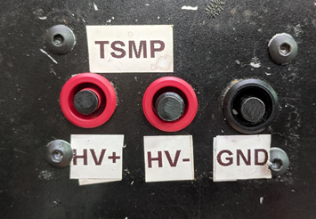

# Accumulator– amendments

5.2 – Cells: cell mounts are constructed from brass material not aluminium. Below is a photo from confirmation (addendum implemented)

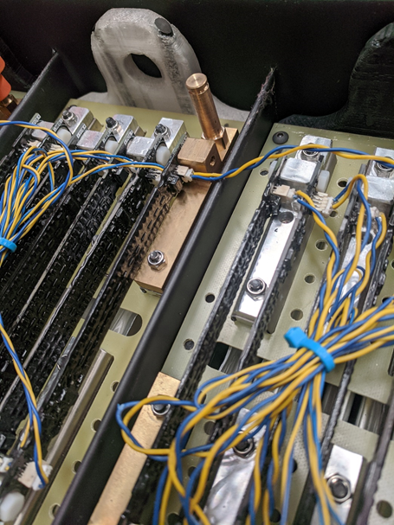

Addendum implemented